# Cyclone PCB Factory Gui Tutorial

by Kobus du Toit

Contents

Cyclone PCB Factory Gui Tutorial 1

Installation 3

Install Python with NumPy 3

Install PySerial 3

Install PyPy 5

Install Java 5

Change Python code 6

1_GenerateGcode.py 6

2_Zprobe.py 7

3_Send.py 7

configuration.py 7

Configure the GUI 8

Create a board 10

Current issues 11

# Installation

## Install Python with NumPy

Download Anaconda Python from <http://continuum.io/downloads> and install it into the root of C:\ drive. The rest of the tutorial will assume Anaconda is in the root of C:\

## Install PySerial

Download PySerial from <https://pypi.python.org/pypi/pyserial>

Open the pyserial-2.6.tar.gz file with 7-Zip or another tool that can read .gz files

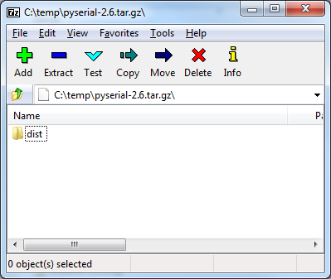

Double click on the dist folder

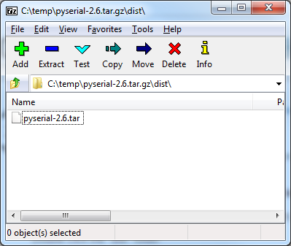

Double click on the pyserial-2.6.jar file

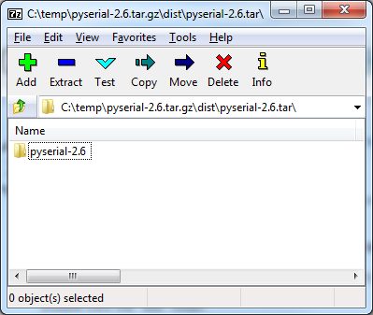

Click on the extract button and choose the site-packages folder in the Anaconda Python installation, e.g. C:\Anaconda\Lib\site-packages

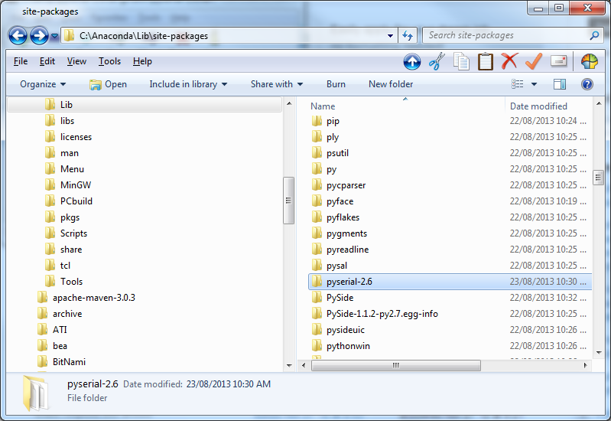

Open a command prompt

Change directory to C:\Anaconda\Lib\site-packages\pyserial-2.6 and install the new package using C:\Anaconda\python.exe setup.py install

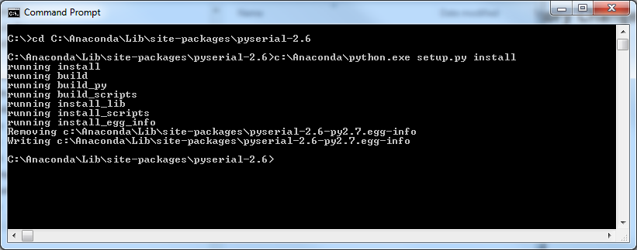

## Install PyPy

Download PyPy from <http://pypy.org/download.html> and install it

## Install Java

Download Java from <http://www.oracle.com/technetwork/java/javase/downloads/jdk7-downloads-1880260.html> and install it

## Change Python code

Go to the Software directory in Cyclone-PCB-Factory, e.g. C:\Util\Cyclone-PCB-Factory-master\Software

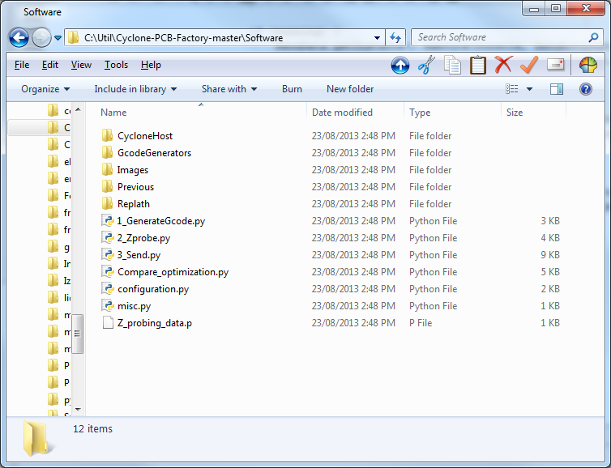

## 1_GenerateGcode.py

Edit 1_GenerateGcode.py with Notepad++ or Textpad or your favourite editor

**Change the following lines**

call(["python","./pygerber2gcode_cui_MOD.py"])

# call(["pypy","./pygerber2gcode_cui_MOD.py"]) # If you have "pypy" installed go ahead!

**To**

#call(["python","./pygerber2gcode_cui_MOD.py"])

call([sys.argv[1],"./pygerber2gcode_cui_MOD.py"]) # If you have "pypy" installed go ahead!

**Change the following lines**

print("Press enter to exit...")

val = sys.stdin.readline()

**To**

#print("Press enter to exit...")

#val = sys.stdin.readline()

## 2_Zprobe.py

Edit 2_Zprobe.py

**Change the following lines**

print("Press enter to exit...")

val = sys.stdin.readline()

**To**

#print("Press enter to exit...")

#val = sys.stdin.readline()

## 3_Send.py

Edit 3_Send.py

**Change the following lines**

print("Turn on the spindle and press enter to begin...")

val = sys.stdin.readline()

**To**

#print("Turn on the spindle and press enter to begin...")

#val = sys.stdin.readline()

**Change the following lines**

print("Done. Press enter to exit...")

val = sys.stdin.readline()

**To**

#print("Done. Press enter to exit...")

#val = sys.stdin.readline()

## configuration.py

Remove all comments from the file, everything that has a hash (#) infront of it

# Configure the GUI

Open a command prompt and go to the directory where the jar file is

Run the GUI using java -jar Cyclone-PCB-Factory-Gui.jar

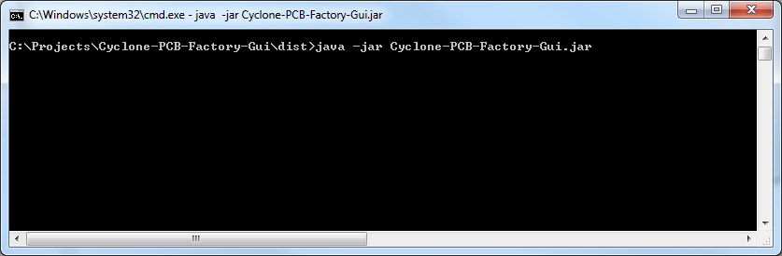

The GUI window will open

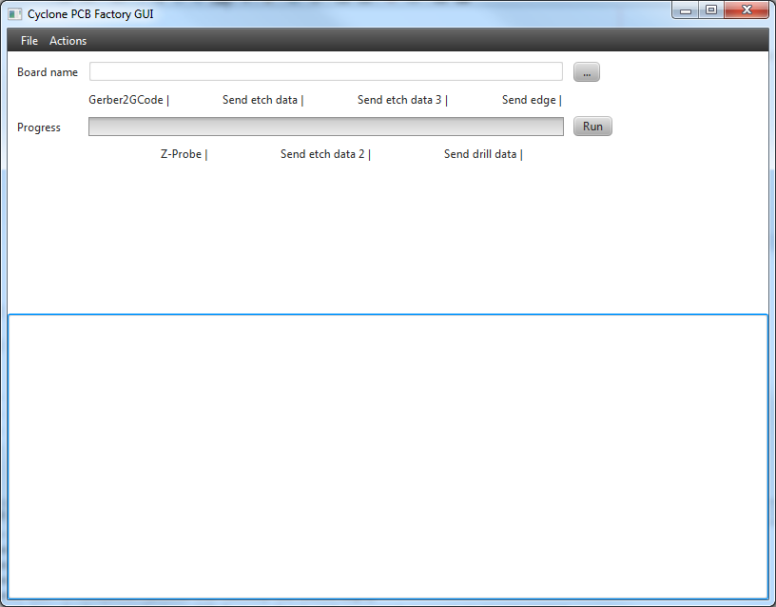

Go to File | Properties and populate all the values. Click save to store the new properties

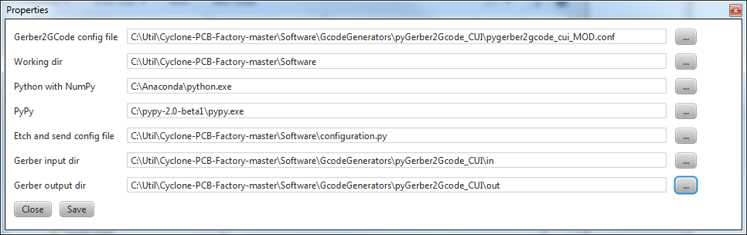

Choose a board on the main screen. When clicking on the button with 3 dots “...” a dialog box will open up and a drl file can be chosen

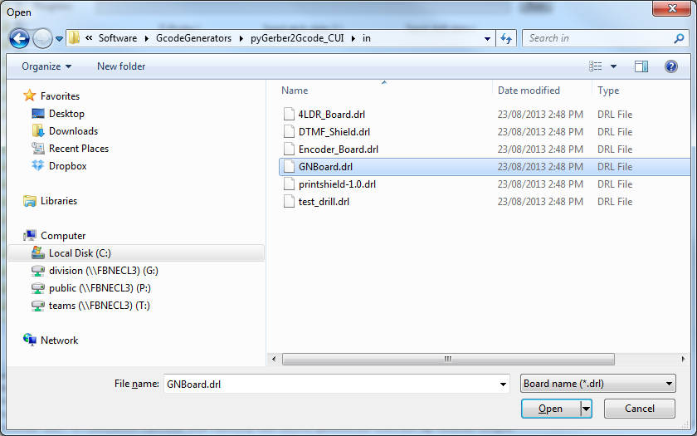

The board name will be populated on the main screen

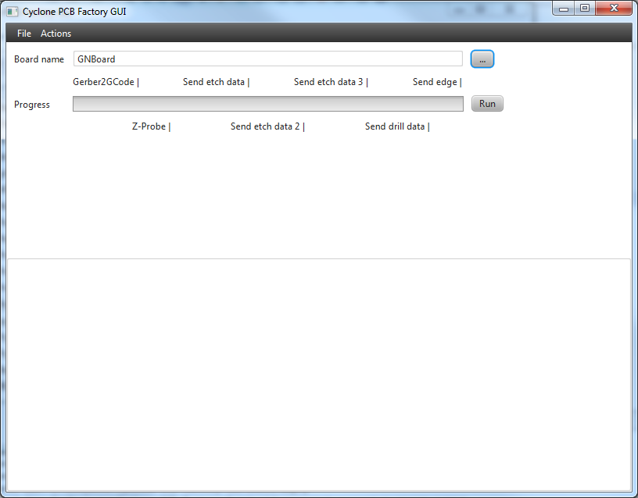

# Create a board

All the actions can be run in one go by clicking on the Run button on the main screen or each action can be run separately by going to the Actions menu and selecting the correct action.

Please note: If the actions are not executed in the correct order the configuration files might not have been setup correctly and the wrong data might be sent to the machine

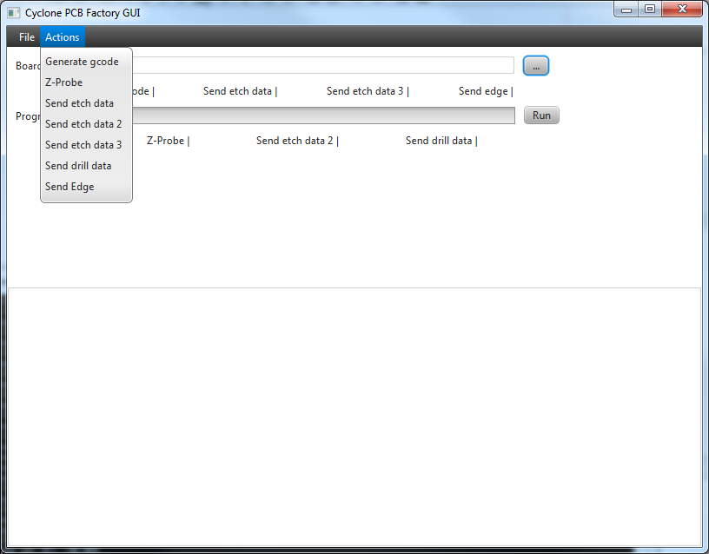

# Current issues

1. The console is only updated continuously when 1_GenerateGcode.py aka “Generate gcode” is executed, all other python scripts block for a long time.
2. There is a problem between how Java writes directories and how Python reads it from the configuration files. The gerber files should still be stored in ./GcodeGenerators/pyGerber2Gcode_CUI/in/ and the output files will still go to ./GcodeGenerators/pyGerber2Gcode_CUI/out/. Please make sure to select these directories when setting the input and output directories in the Properties of the app

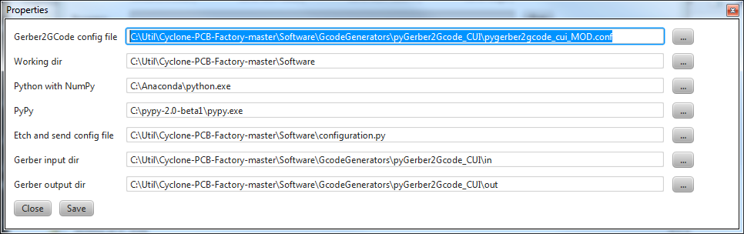

1. The python code opens a window. The window hangs on my environment and doesn’t display anything
2. The text area is editable by the user